Code reference:

All the code over here in this project has been taken from these sources

<https://github.com/samlopezf/google-drive-api-tutorial>

<https://developers.google.com/drive/api/v3/manage-uploads>

|  |
| --- |
| * describe what is google docs * describe what is goole drive * contrast them * locate a google drive python interface and create an example * locate a google docs python interface and create an example   <https://www.cloudwards.net/how-does-google-drive-work/>  <https://whatis.techtarget.com/definition/Google-Docs>  <https://www.techopedia.com/definition/13626/google-docs>  Google Drive is a file storing platform where an user can store all his/her files in the google drive. Here files can be of any form ranging from documents to audio / video or image files. In free account each user will be given around 15 GB of free data space to be stored. We can create folders and subfolders in the Google Drive to store our data. Each file will be stored in Google cloud with a unique URL and it’s up to the user to make the file sharable or not. Google Drive is reliable and if an user has different devices and if he/she wants to access those files then Google Drive is needed in this case as he can have access to his file as all his files are stored in the cloud. The user does not need to install any kind of software in order to view these files.  Google docs is especially designed for viewing or editing or sharing the documents like Docs, Sheets, Slides, Forms. No need to install any software to access or edit these. Ant google doc can be sharable with editable option. There is an automatic mechanism to convert Microsoft documents to Google Docs.  Google Docs  Google Sheets  Google Slides  Google Forms  In a broader picture Google docs is just a subset of Google Drive  Setting up a gmail account for the project  Taking screenshots during this process  Making the project setup for the code  Restructuring the code with more details |

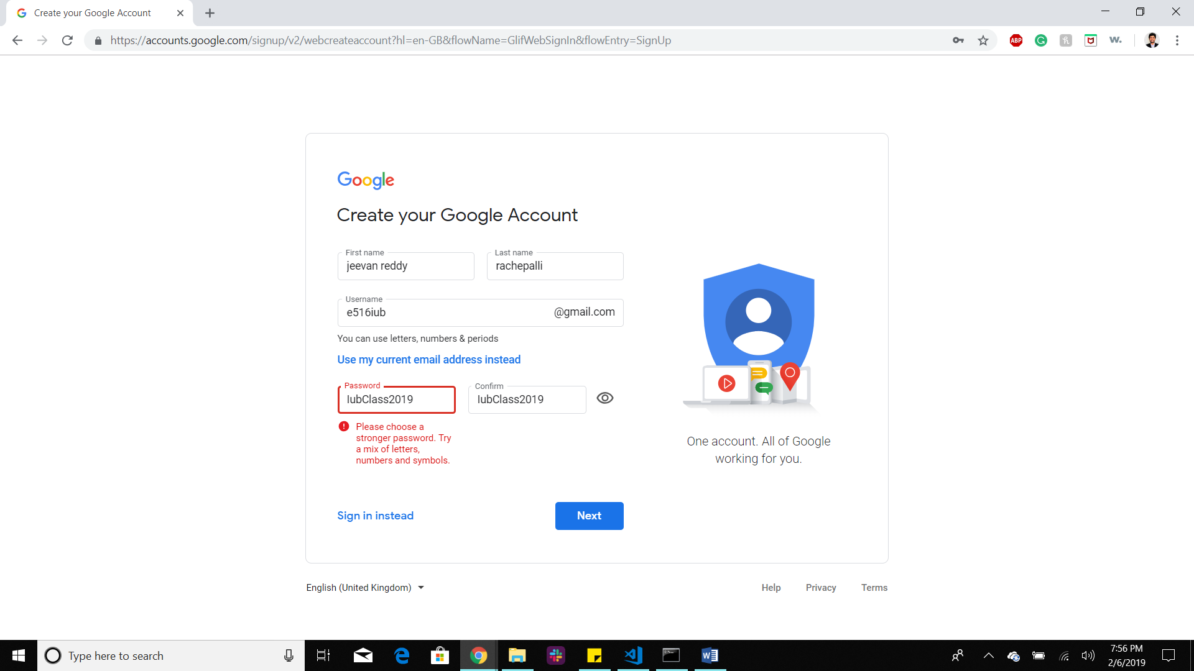

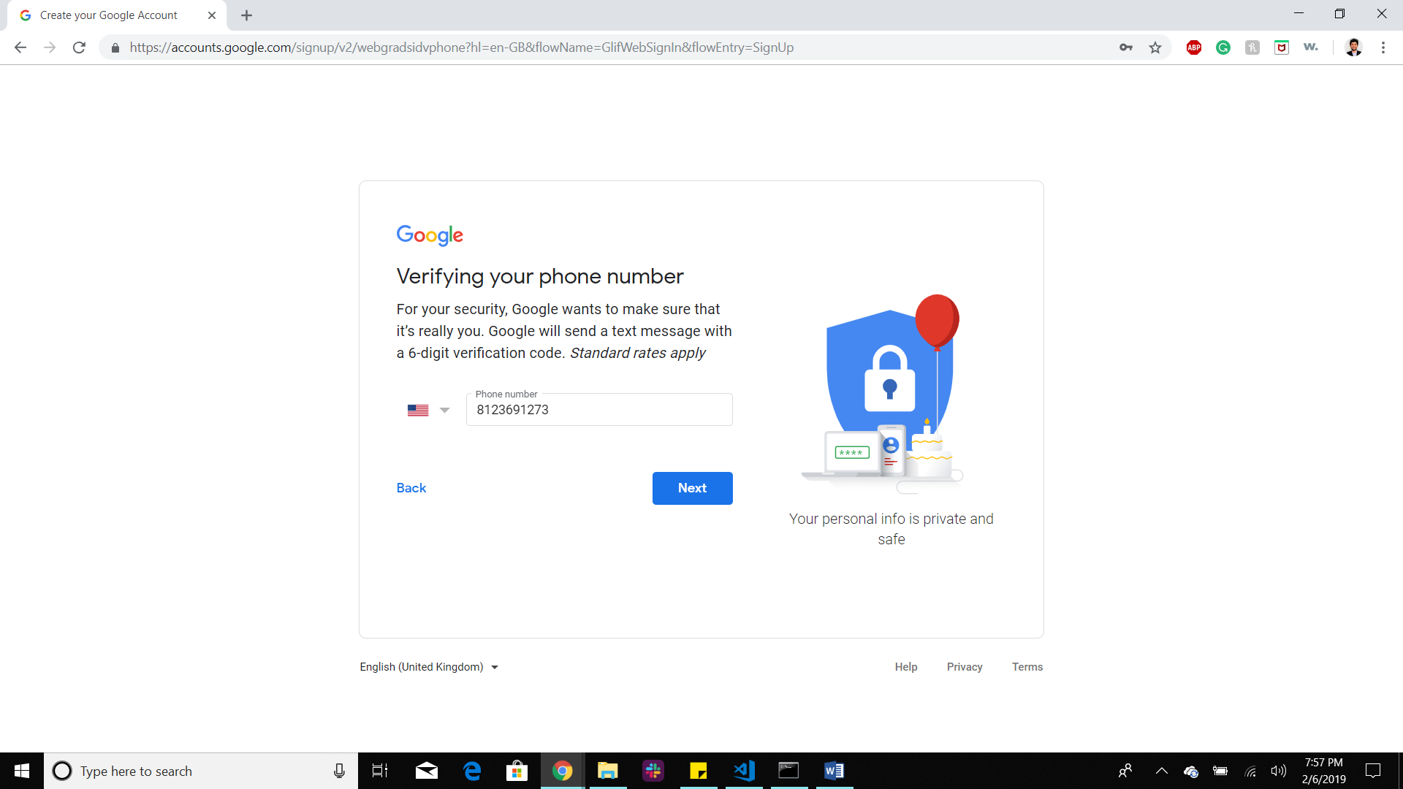

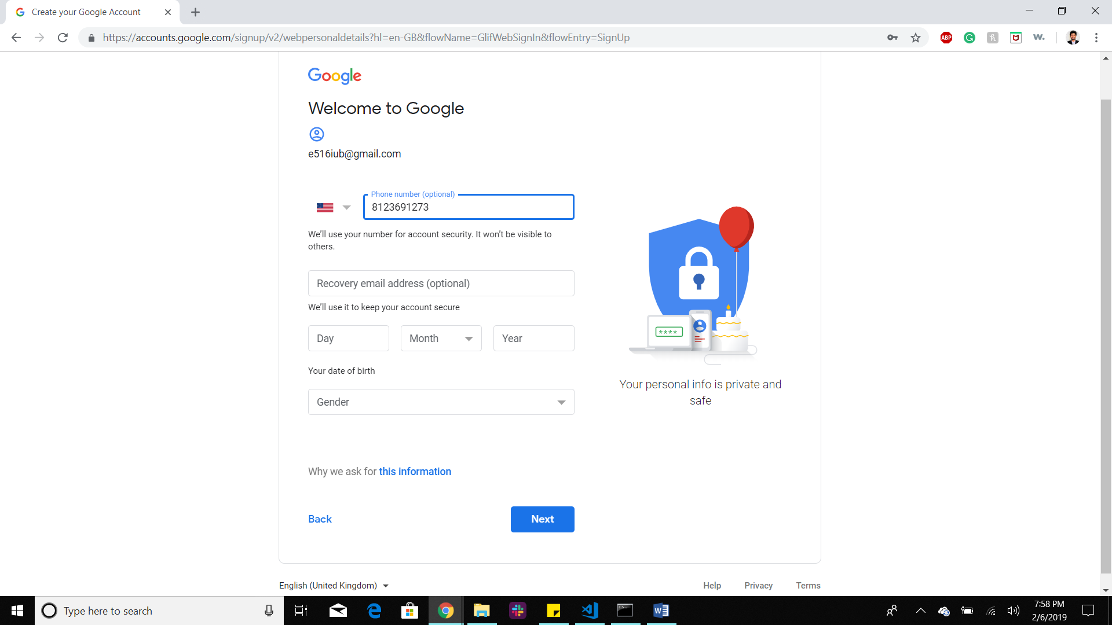

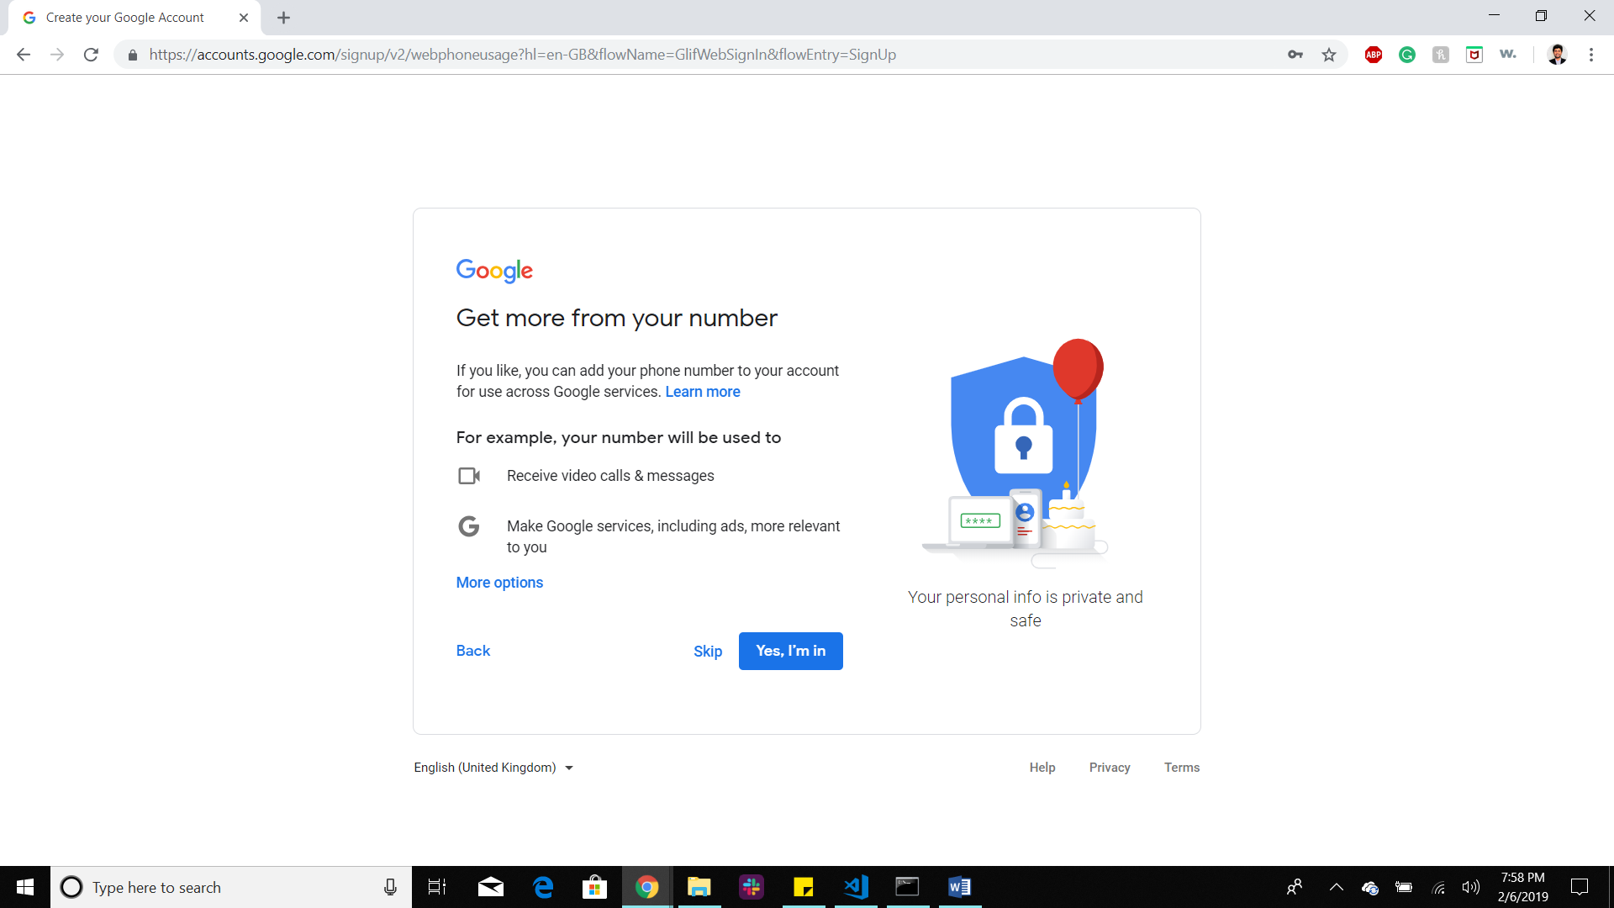

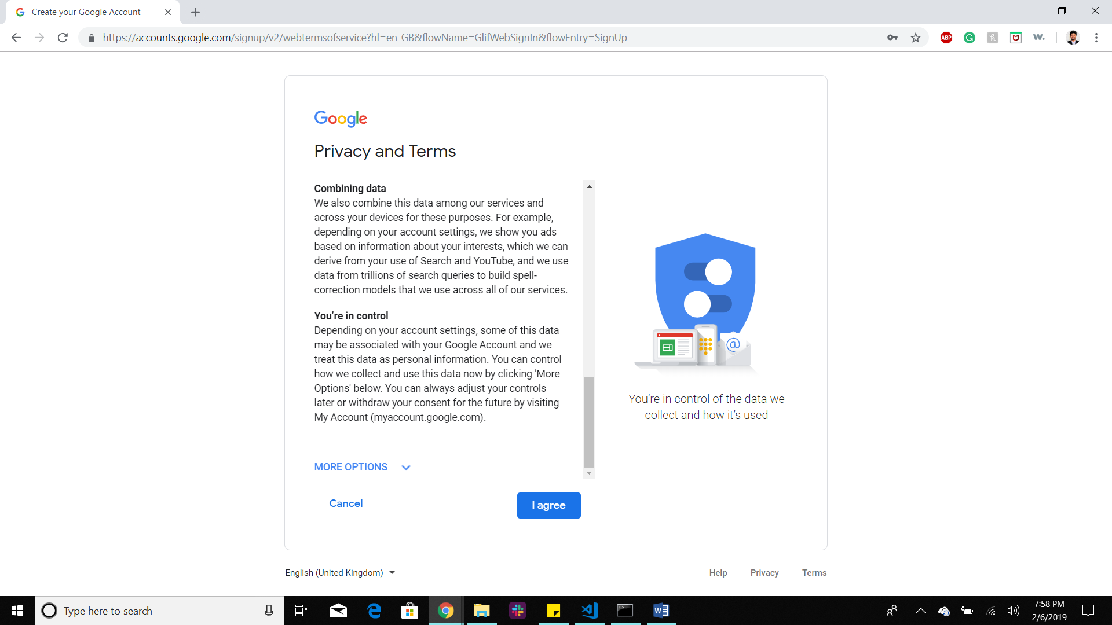

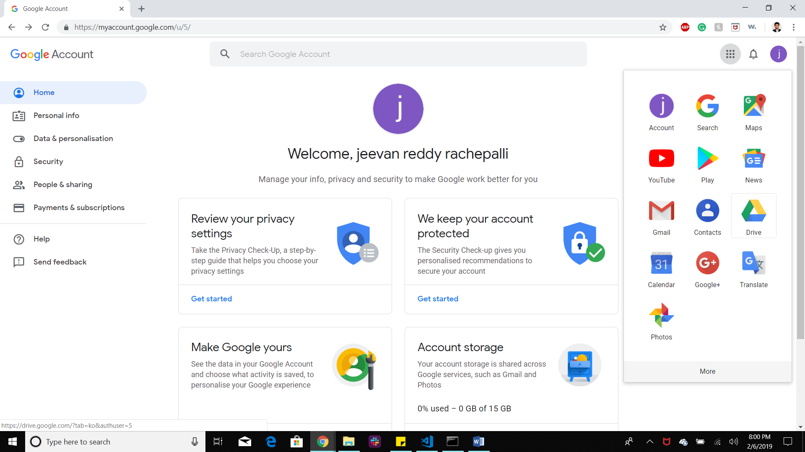

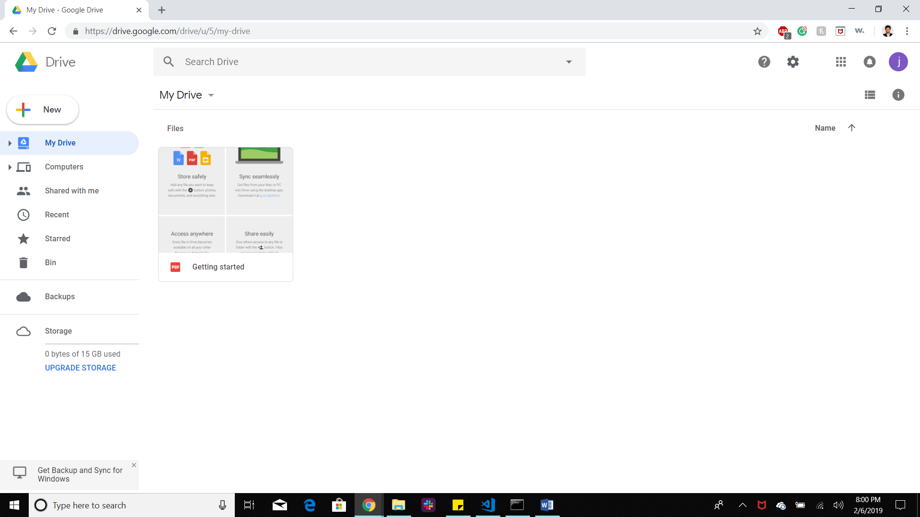

<https://developers.google.com/drive/api/v3/quickstart/python>

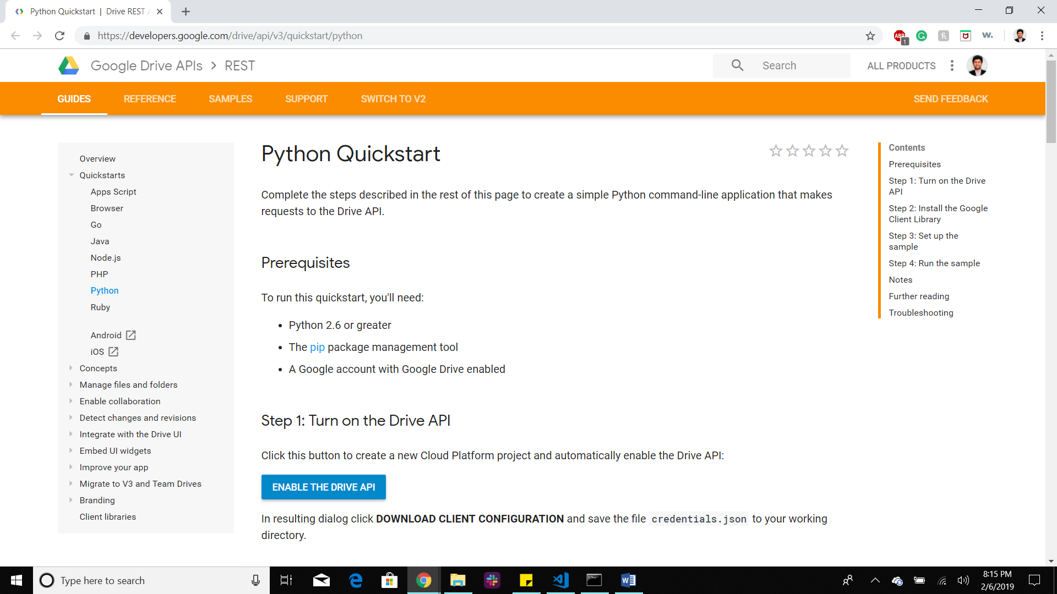

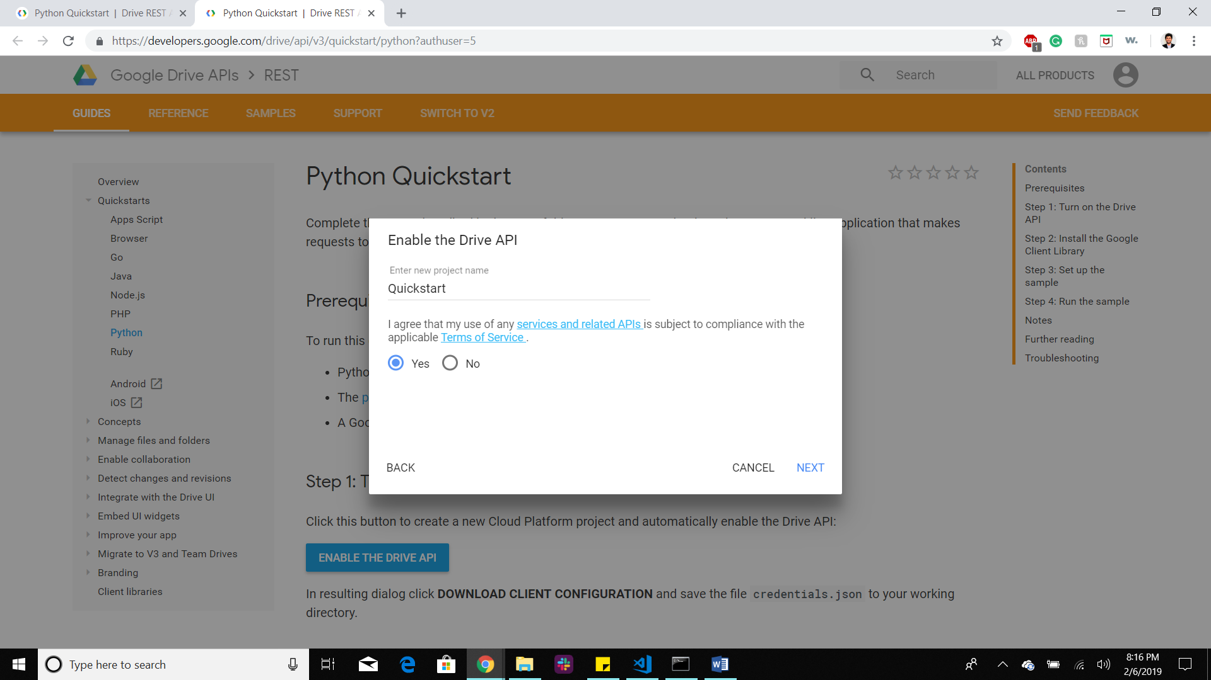

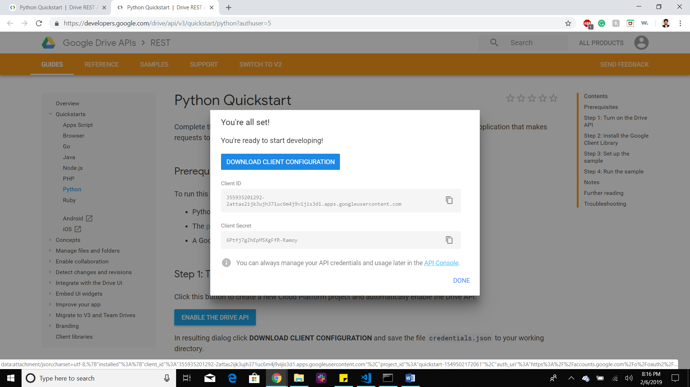

We will get credentials.json

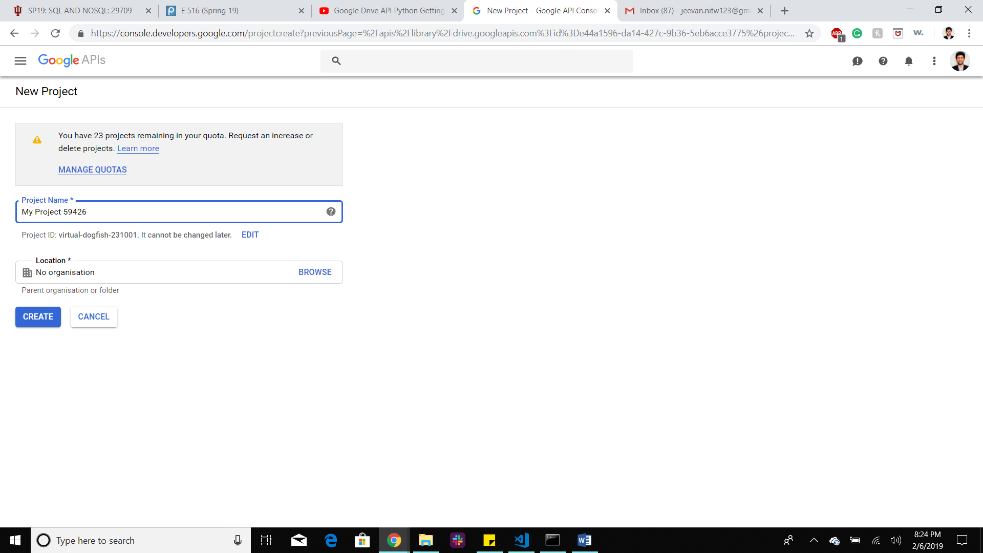

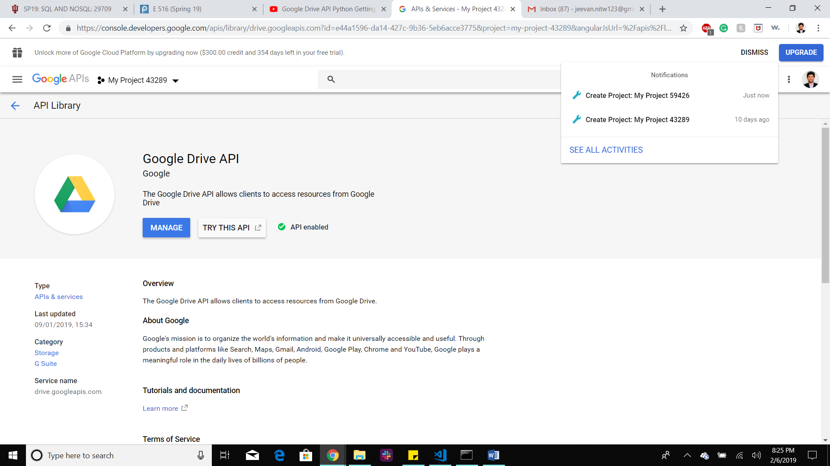

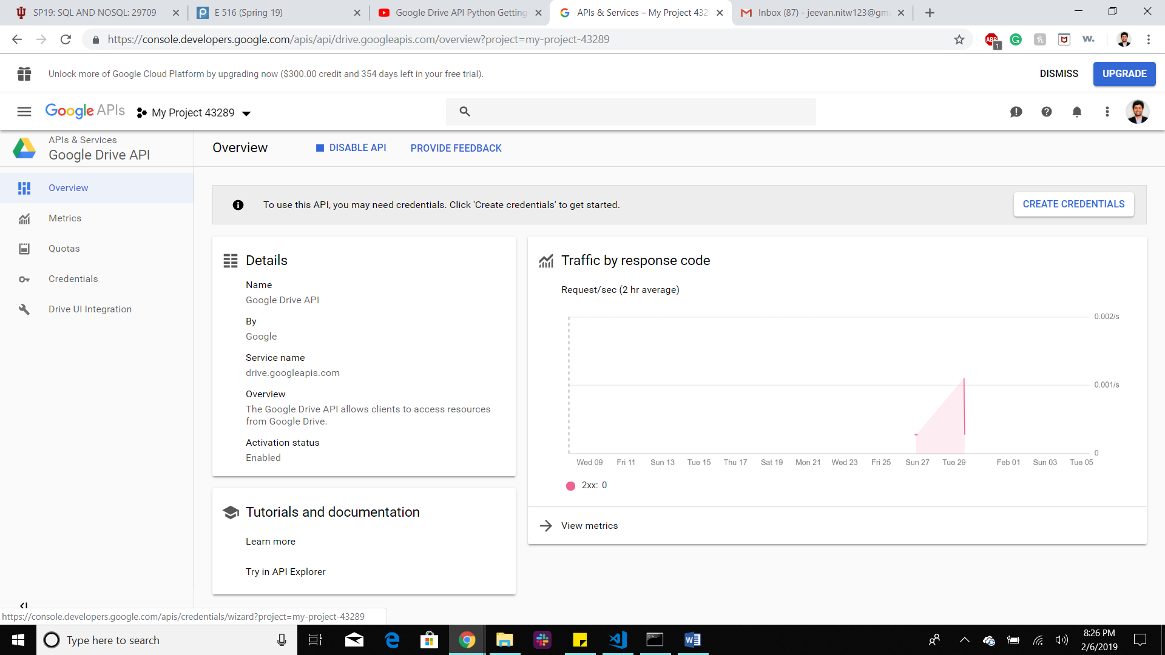

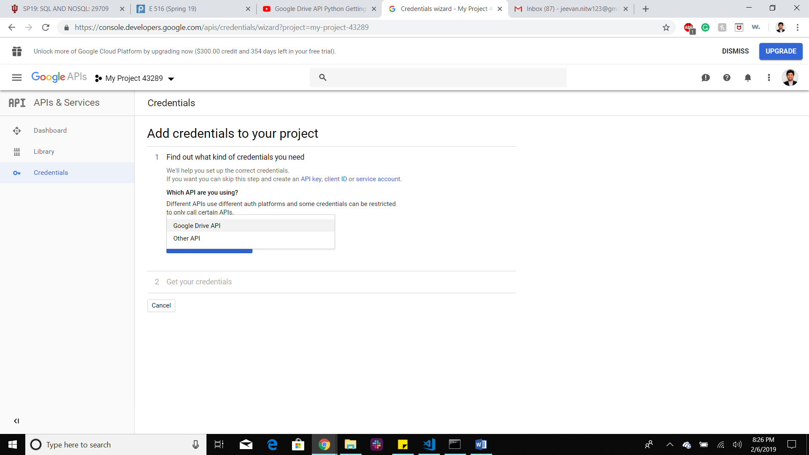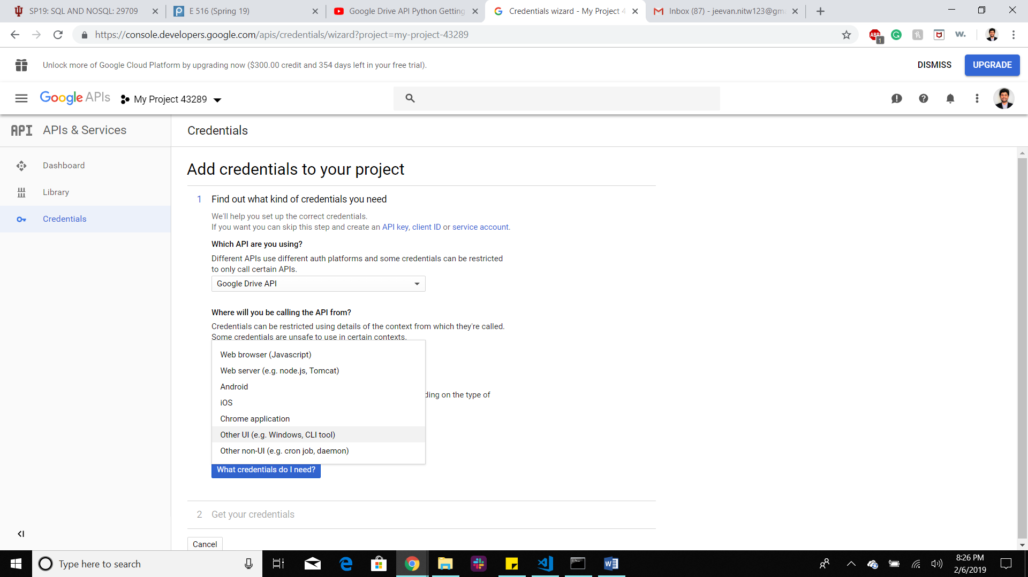

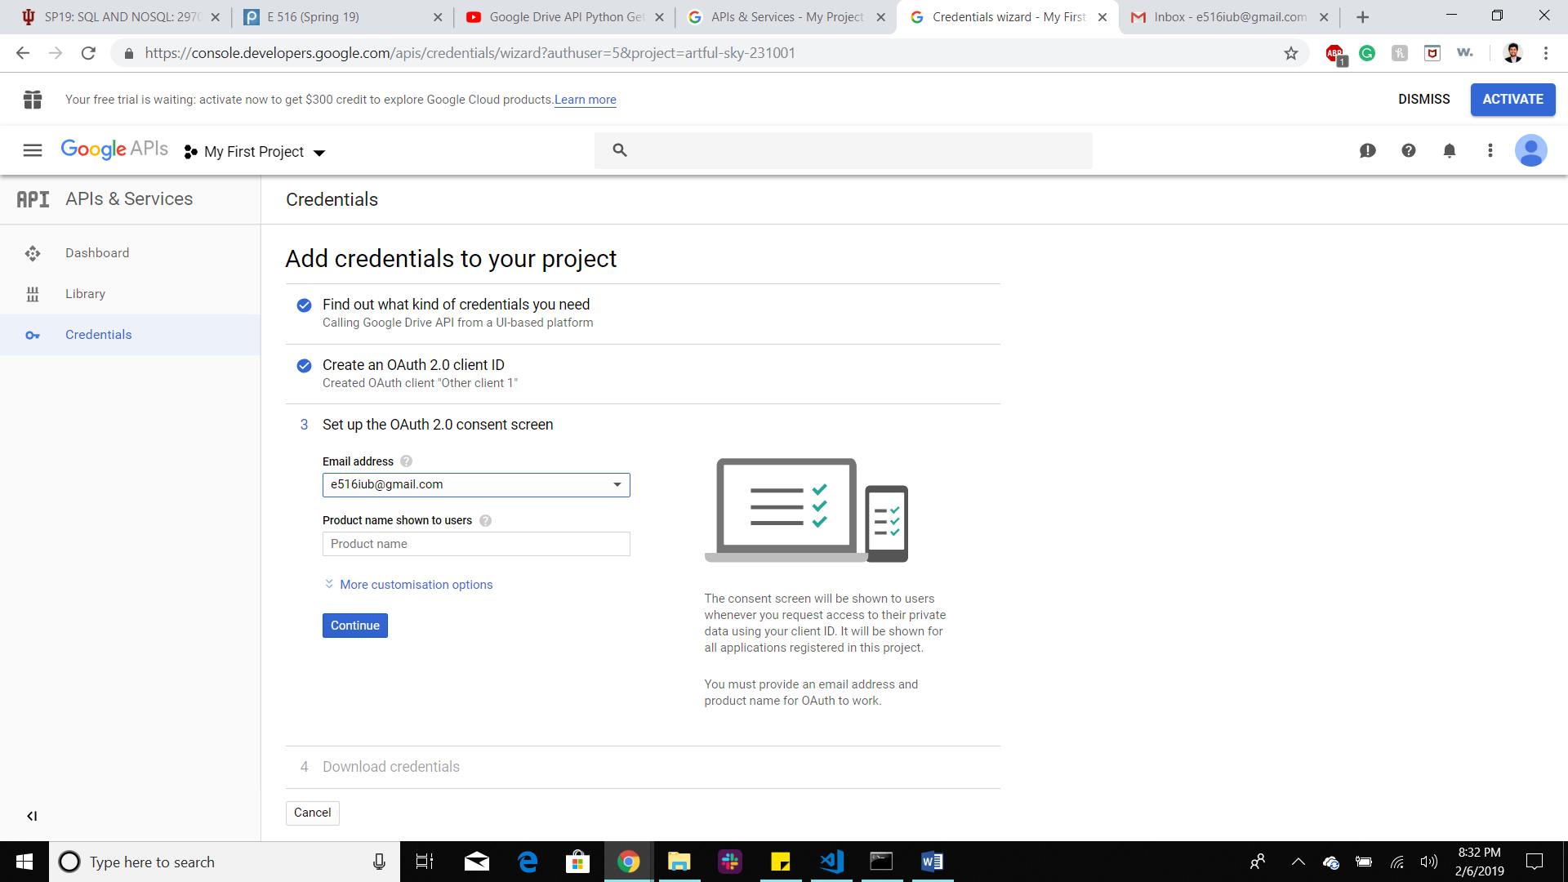

Google Drive API Tutorial

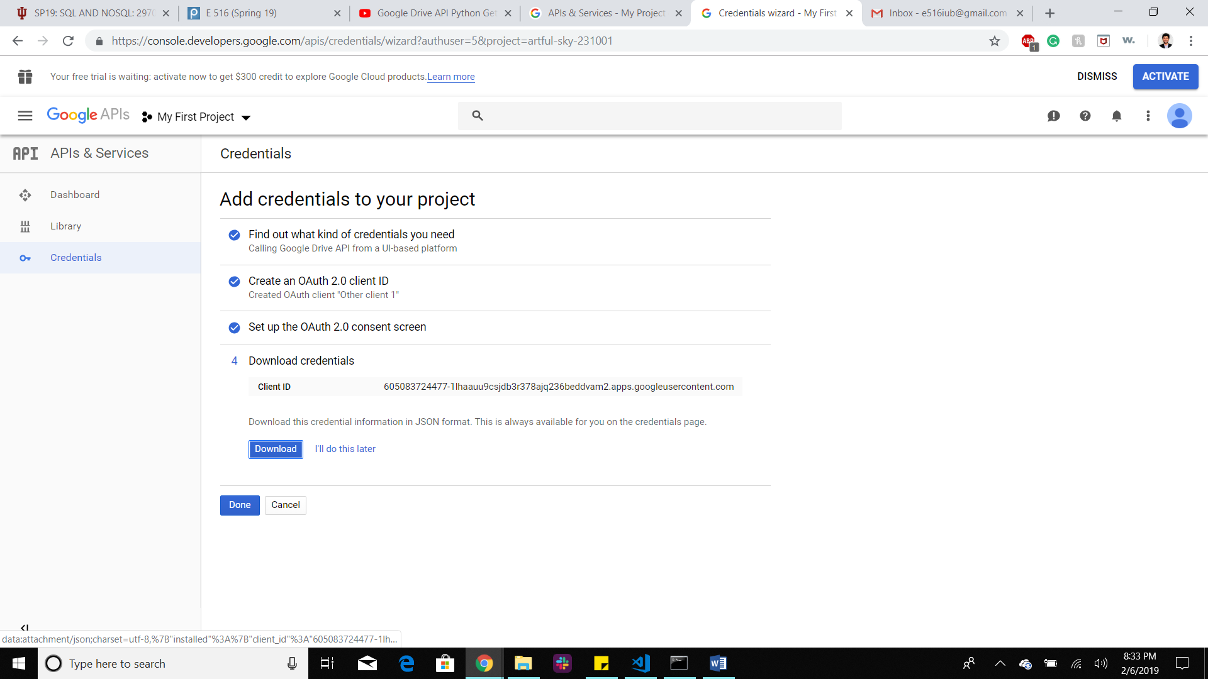

Client_id.json

